**International University**

School of Electrical Engineering

**Principle of EE1 Laboratory**

**EE052IU**

**[Lab 4]**

**Operational Amplifiers**

**Submitted by**

[Đỗ Minh Duy - ITITSB22029]

[Nguyễn Đức Anh - EEACIU23005]

Date Submitted: [28/12/2024]

Date Performed: [18/11/2024]

Lab Section: [4]

Course Instructor: [Nguyen Minh Thien]

**GRADING GUIDELINE FOR LAB REPORT**

|  |  |  |  |  |
| --- | --- | --- | --- | --- |
| **Number** | **Content** |  | **Score** | **Comment** |
| 1 | **Format (max 9%)** | |  |  |
| * Font type | Yes No |  |
| * Font size | Yes No |  |
| * Lab title | Yes No |  |
| * Page number | Yes No |  |
| * Table of contents | Yes No |  |
| * Header/Footer | Yes No |  |
| * List of figures (if exists) | Yes No |  |
| * List of tables (if exists) | Yes No |  |
| * Lab report structure | Yes No |  |
| 2 | **English Grammar and Spelling (max 6%)** | |  |  |
| * Grammar | Yes No |  |
| * Spelling | Yes No |  |
| 3 | **Data and Result Analysis (max 85%)** | |  |  |
| **Total Score** | |  | |  |

Signature:

Date:

**Table of Contents**

List of Figures ........................................................................................….….................................3

List of Tables .................................................................................................……..........................3

Nomenclature ...........................................................................................................…….…..........4

Theoretical Background .............................................................................................…….............4

Experimental Procedure.............................................................................................……..............3

Experimental Results ........................................................................................................………...4

Discussion of Results .......................................................................................................................4

**List of Figures**

Figure 1 –………………………….……...…………………………………………………… 4

Figure 2 – …………………………………………………………………..……………...….. 5

Figure 3 – ……………………………………………………………………………………... 7

Figure 4 –………………………………………….………………………..……………...….. 8

Figure 5 – ……………………………………………………………………………………... 8

Figure 6 – ……………............................................................................................................... 10

Figure 7 –………………………….……...…………………………………………………… 11

Figure 8 – …………………………………………………………………..……………...….. 12

Figure 9 – ……………………………………………………………………………………... 13

Figure 10 –………………………………………….………………………..……………...….. 13

Figure 11 – ……………………………………………………………………………………... 14

Figure 12 – ……………............................................................................................................... 14

Figure 13 –………………………….……...…………………………………………………… 15

Figure 14 – …………………………………………………………………..……………...….. 15

Figure 15 – ……………………………………………………………………………………... 17

Figure 16 –………………………………………….………………………..……………...….. 17

Figure 17 – ……………………………………………………………………………………... 18

Figure 18 – ……………............................................................................................................... 18

Figure 19 –………………………………………….………………………..……………...….. 20

Figure 20 – ……………………………………………………………………………………... 21

**List of Tables**

Table 1 – ……………………………………..……………………........................................... 21

**Nomenclature**

VDD = DC Voltage Source

Vdd = AC Volatge Source

Iref = Reference Current

**Theoretical Background**

**1. Op-Amp Terminal Characteristics**

The Fig. 1 illustrates a 741 Op-Amp. It has two input terminals where the input voltage Vi is measured. These terminals are known as inverting (Vn) and non-inverting (Vp), leading to Vi=(Vp-Vn). The output, Vo, is measured against the ground. Extra terminals like V+ or +Vcc, V- or -Vcc, serve purposes like bias and offset.

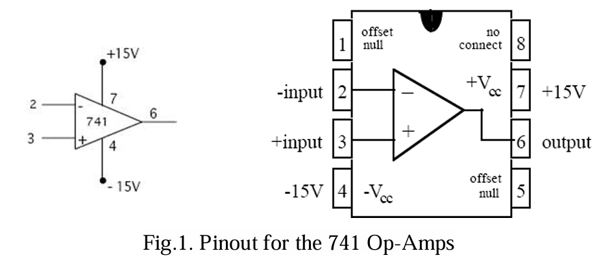

The operational amplifier's realistic model, as per your textbook and depicted with equivalent symbols, includes distinct input and output sections. The input features an input resistance Ri across the inverting and noninverting terminals. The output involves a voltage dependent voltage source (with voltage AvVi) in line with an output resistance Ro. It's important to note that the dependent source's proportionality relation is the sole link between the input and output.

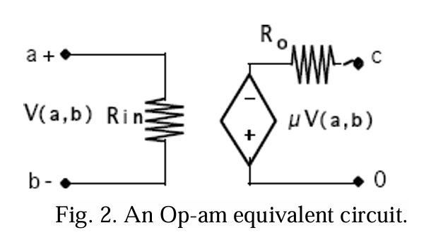

**a. Input Voltage Vi:** V(a,b)=Vi=(Vp-Vn)

**b. Output Voltage Vo:** This is proportional to the input as long as it’s smaller than in absolute terms of the DC bias voltages V+ and V-. .

**c. Input Resistance R:** This resistance sits between the inverting and noninverting terminals with Vi across it. It's determined by dividing the input voltage Vi by the current entering Vp or leaving Vn.

**d. Open Loop Voltage Gain μ or Av:** This gain is the proportionality constant in the dependent source equation where V = AvVi (or V=μV(a,b)).

**e. Output Resistance Ro:** This resistance is in series with the dependent source. If Ro isn't zero, the voltage across a load RL isn't all of V = AvVi and can be calculated by examining the voltage divider between Ro and RL.

**2. Linear Operation and Saturation**

Op-Amps have two regions of operation: linear and saturation. In the linear region, the voltage transfer characteristic, i.e. the mathematical relationship between the input and output voltages, is linear. This holds true when the output voltage lies in the range:

From the earlier definition of voltage gain, which is Vo = AvVi, it can be inferred that this range aligns with input voltages within a certain range.



In this range, the output voltage is directly proportional to the input voltage, by the factor Av.

If the input voltages fall outside this range, the Op Amp is said to be in the saturation region. In this region, its output is limited by the DC bias voltages. Specifically, the output voltage is limited to V- when ViV+/Av. This essentially means that the output cannot exceed these voltage limits, regardless of the input.

**3. Ideal Op-Amp**

a. Ri = ∞: According to the definition of input resistance given above, an infinite input resistance indicates that no current enters or exits the op-amp's input terminals. This reduction greatly facilitates the analysis of op-amp circuits.

b. Ro = 0: The dependent source voltage is either input into another device or present across the load resistance when the output resistance is zero. This suggests that the output resistance of the op-amp is not causing any voltage drop across its output, which is another helpful simplification for circuit analysis

c. μ =AV = ∞: If the output voltage isn't saturated, the input will become closer to zero (Vi ≈ 0) with infinite voltage gain when negative feedback is present. Calculations are made simpler by creating a virtual short circuit between the input terminals. Both terminals are at zero voltage when

one is grounded, forming a virtual ground.

**4. The Inverting Amplifier**

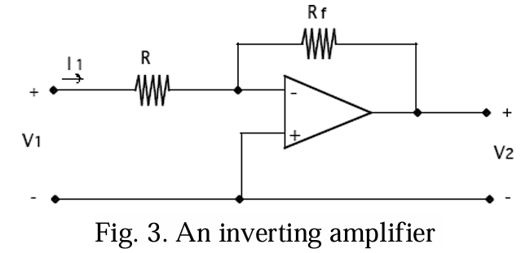

Circuit analysis of the inverting amplifier in Fig. 3 yields the equation,

V2 = K V1 = (-Rf/R)V1 (1)

Thus, the theoretical gain K of the whole stage (that is, the entire Op-Amp circuit of Fig 3.) is given by

K = V2/V1= (-Rf/R)

**5. The Non-Inverting Amplifier**

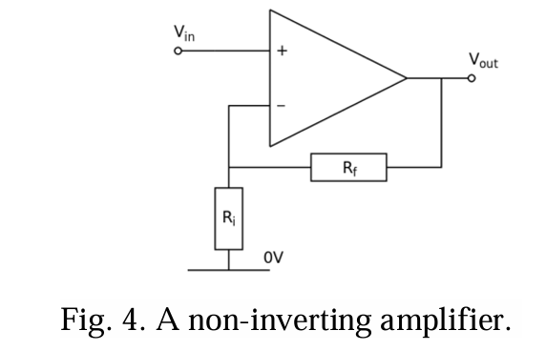

Circuit analysis of the non-inverting amplifier shown in Fig. 4 yields the equation,

V2 = (1+Rf/R)V1 (2)

Thus, the theoretical gain K of the whole stage is given by

K = V2/V1= (1 + Rf/R)

**6. Oscilloscope**

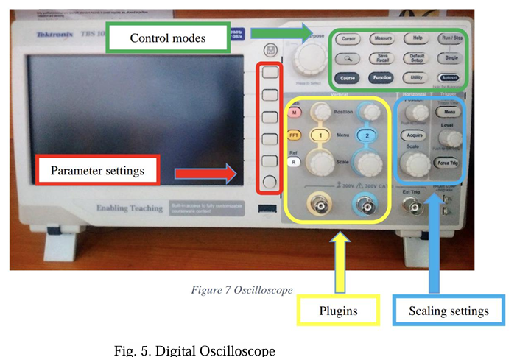

In this lab section, Mr.Thien, taught us a method to use the functions of this powerful machine, which will accompany EE’s students for further lab.

An oscilloscope is an essential tool in electronics, primarily used to graphically display how signal voltages change over time. It allows users to measure voltage (both peak-to-peak and RMS), determine the frequency of oscillating signals, and compare the phase and delay between two signals. Additionally, it can measure the duration of pulses in digital systems and analyze signal integrity by detecting abnormalities such as noise, jitter, and other distortions. Proper use of an oscilloscope requires an understanding of voltage and time scales, trigger types, and other pertinent settings.

**Using oscilloscope**

1. Press the Default Setup in the first step when using the Oscilloscope
2. Connect wire into the machine then check the wire if it still works
3. When using the machine, check and set the probe turn to 10x
4. Attach the probe to the machine's probe comp if you want to check the probe can be used; if it's still functional, a square wave will appear on the screen. (5V@1kHz)
5. The trigger buttons for synchronizing (at 0 in default)
6. Using the Cursor button to measure the Voltage peak, Time or Using the Measure button to see all the statistics (must scale correctly so that the machine will give the exact value).

During the lab session, it's important to keep in mind several key points: verifying the functionality of the probe, configuring the scale for simplified readings of amplitude and period, as well as adjusting the cursor. Remember to engage the 10X mode on the probe and reaffirm its activation on the display.

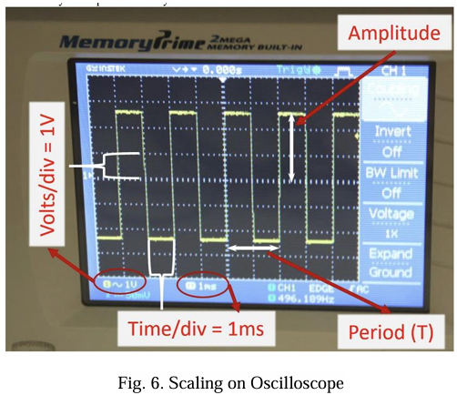

**Experimental Procedure**

**Setting up first**

Adjust the Function Generator and check the wire

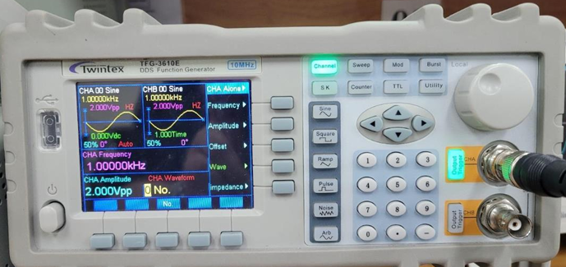

**Figure 7**

Step 1: Connect the wire to the channel input (CHA/ CHB) and the other head to the lead (+) RED and the (-) BLACK of the circuit.

Step 2: Set up the Frequency to 1000 Hz, the Amplitude to 2V (peak-to-peak) and the Sine’s waveform.

Step 3: Turn on the Output Trigger GREEN to begin generating

Adjust the Power Supply and check the wire

**Figure 8**

Step 1: Connect two output channels to the OpAmp: The first (+) input RED to the port (4) to and the GND, the other (+) RED connect to the port (7) and the GND.

Step 2: Set up the Current to 5V and Voltage to 12V for both channels.

Step 3: Press the button “serries” and plug out one cable to make it become ground, so we have 2 output with -12V and +12V to supplied for op-amp.

Step 4: Turn on the Output Button RED to begin generating.

1. **Experiment 1: Inverting Amplifier**

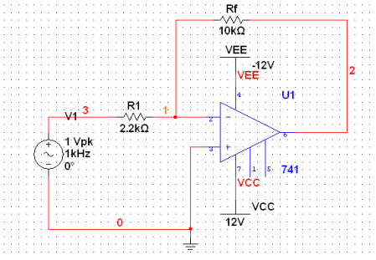

**Figure 9**

5.1.1 Construct the circuit in Fig. 5 with R1 =2.2kΩ, and Rf =10kΩ, 1V input signal at 1Khz. Measure the gain. Sketch the results on the oscilloscope.

We have, Vin = 1.02, Vout=4.6

VGain= Vout/Vin= -Rx/R1 = -4.5454V

Phase diff= 179

**Figure 10**

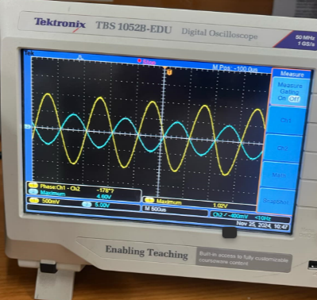

**Figure 11**

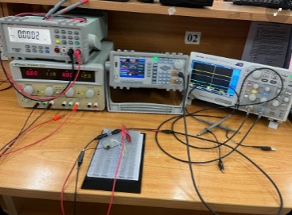

**Figure 12**

5.1.2 Calculate and measure the gain with R1 = 2.2kΩ and Rf = 100kΩ. Compare results with

previous case. Sketch the results on the oscilloscope.

We have, Vin=1.02V, Vout=12.2V

VGain= Vout/Vin= 12.2/1.02= 11.960V

Phase Diff= phi(1)-phi(2)= 174 degree>0

**Figure 13**

**Figure 14**

a. Compare the measured/simulated output signal in 5.5.1 and 5.1.2? Explain the differences.

The differences in output voltage between the two setups are due to the change in the feedback resistor (Rf). Increasing Rf increases the gain of the non-inverting amplifier, which in turn increases the output voltage. The slight differences between simulation and actual measurement can occur due to real-world variations in component values.

b. Find the phase difference between the input and output of inverting amplifier? Why is this called an inverting amplifier?

In an **inverting amplifier**, the phase difference between the input and output is **180 degrees**. This means that when the input signal is at its positive peak, the output signal will be at its negative peak, and vice versa.

The term "inverting" is used because the amplifier inverts the phase of the input signal. The output signal is the negative scaled version of the input signal. If the input signal is Vin, the output Vout is given by: Vout = -A * Vin

The inverting amplifier uses the inverting (-) terminal of the operational amplifier, where the input signal is applied. The non-inverting (+) terminal is grounded or held at a constant voltage, reinforcing the phase inversion property.

**Comparison table**

In this section, we can observe that in an inverting op-amp, the phase differences between input and output voltage should be 180 degrees.

|  |  |  |  |  |
| --- | --- | --- | --- | --- |
| Rf | Vin | Vout | Vgain | Phase difference |
| 10k | 1.02 | 4.6 | -4.5 | 179 |
| 100k | 1.02 | 12.2 | 11.96 | 174 |

**2. Experiment 2: Non-Inverting Amplifier**

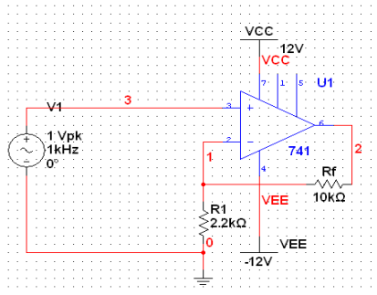

**Figure 15**

5.2.1 Construct the non-inverting amplifier with R1 = 2.2kΩ and Rf = 10kΩ. Measure the gain.

**Figure 16**

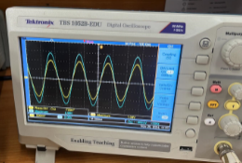

**Figure 17**

We have, Vin=1.04, Vout=5.68

Vgain= Vout/Vin = 5.46V

Phase diff= 0

5.2.2 Repeat section 5.2.1 with R1 = 2.2kΩ and Rf = 100kΩ. Compare the results.

**Figure 18**

We have, Vout=12.2, Vin=1.04

Vgain= 11.73

Phase diff=3.85

a. Compare the measured/simulated output signal in 5.2.1 and 5.2.2? Explain the differences.

The differences in output voltage between the two setups are due to the change in the feedback resistor (Rf). Increasing Rf increases the gain of the non-inverting amplifier, which in turn increases the output voltage. The slight differences between simulation and actual measurement can occur due to real-world variations in component values.

b. Find the phase difference between the input and output of inverting amplifier? Why is this called an inverting amplifier?

To find the phase difference between input and output of a non-inverting amplifier, apply a sinusoidal signal to the amplifier. Connect both signals to an oscilloscope to display their waveforms. Measure the time delay between the same points on each waveform.

The phase difference is calculated using the formula: Phase Difference (degrees) = (time delay/waveform period) * 360.

(degree)

In this section, using the cursors to determine the time delay which can be displayed on the in 𝜇𝑠 = 10-6 (𝑠). So, in the calculation, we can simplify it as shown as the above formula.

(degree)

In a non-inverting amplifier, the phase difference between the input and output signals is zero degrees. This means the output signal is in phase with the input signal. When the input signal goes high, the output signal goes high, and when the input signal goes low, the output signal goes low. There’s no phase shift, which is why it’s called a non inverting amplifier.

**Comparison table**

|  |  |  |  |  |
| --- | --- | --- | --- | --- |
| Rf | Vin | Vout | Vgain | Phase difference |
| 10k | 1.04 | 5.68 | 5.46 | 0 |
| 100k | 1.04 | 12.2 | 11.73 | 3.85 |

**3. Experiment 3: Comparator using OPAM**

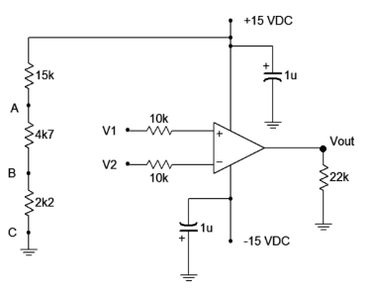

**Figure 19**

5.3.1 The DC voltage at point:

A/ Va = 4.7V

B/ Vb = 1.5V

C/ Vc = 0V

5.3.2 Using the input combinations listed in Table 2, apply the appropriate signals to V1 and

V2. Measure the output voltage and record values in Table 1. Conclude on the working

principle of the OPAM used in the comparison circuit (show the relationship between

V+,V− and VOUT).

**Figure 20**

**Table 1**

|  |  |  |
| --- | --- | --- |
| V1 | V2 | Vout |
| 4.7V | 4.7V | -13.029 |
| 1.5V | -13.031 |
| 0V | 14.51 |
| 1.5V | 4.7V | -13.034 |
| 1.5V | -13.033 |
| 0V | 14.518 |
| 0V | 4.7V | -13.032 |
| 1.5V | -13.032 |
| 0V | 14.513 |

**Discussion of Results**

**1. Inverting OP-AMP**

The close match between the simulated and measured increases shows how accurate the simulation model is and how reliable the components are. The idea that raising Rf raises the amplification factor is demonstrated by the substantial rise in gain that occurs when Rf is raised. The inverting amplifier is a helpful part of signal conditioning, filtering, and amplification since it amplifies the output waveform by a factor of about 10 when Rf is increased.

Because of the inverting nature of the amplifier, the output signal has a 180° phase difference and is an inverted version of the input signal. The validity and dependability of our findings are supported by the fact that our results are in line with those found in other inverting amplifier research. However, in real-world measurements, there might be some variations because of component tolerance, noise, and ambient factors. For accurate results, it is crucial to employ high-quality components and conduct tests under controlled conditions.

**2. Non-Inverting OP-AMP**

Increasing Rf raises output voltages and voltage gain, according to simulation and measurement results. Simulation and measurement accord well, with minor differences attributed to real-world circumstances. It is discovered that the non-inverting amplifier's input and output have a zero degree phase difference. The experiment confirms the theoretical knowledge of the behavior of non-inverting amplifiers. Resistor tolerances and op-amp flaws are two possible sources of inaccuracy. The behavior of non-inverting amplifiers under different feedback resistor values was successfully explored. insightful information for real-world applications and theoretical idea reinforcement.

**3. Comparator using OPAM**

The operational amplifier (OP-AMP) serving as a comparator was the main focus of this investigation. For the majority of inputs, the results were consistent with theory: output voltage attained positive saturation when V1 was greater than V2, and vice versa. Contrary to the theory, which states that under such circumstances the output should be 0 or undefined, the output stayed close to positive saturation when V1 equaled V2.

This disparity may result from measurement mistakes, external interference, or the less-than-ideal behaviors of actual OP-AMPs. It emphasizes how crucial it is to take component limits into account when designing circuits, particularly for applications requiring precision.

The understanding of OP-AMP comparators in electronics applications could be improved by future research that investigate this discrepancy using various OP-AMP kinds or enhanced measuring techniques.